DOROTEO ROSE ANN BARRACA
BSIT 3F2

- SAMPLE CLASS DIAGRAM
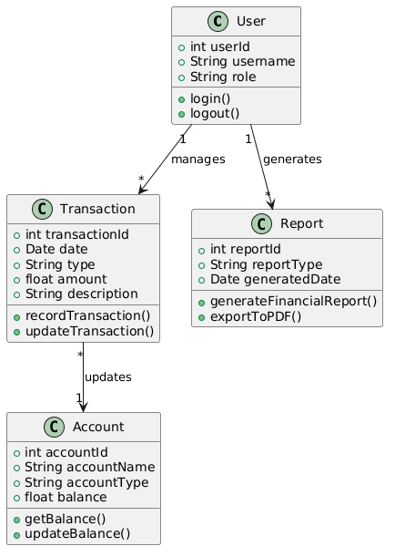
- Sample Diagram 0
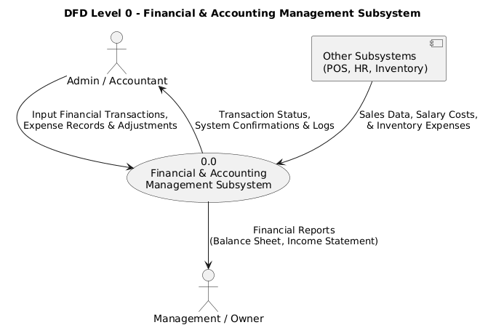

- ER Diagram
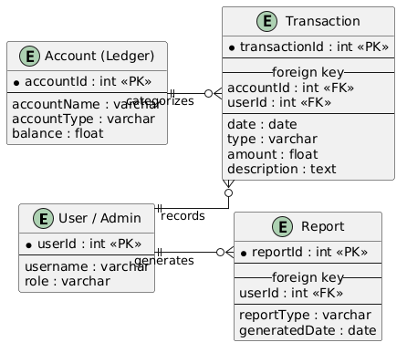

- .ACTIVITY DIAGRAM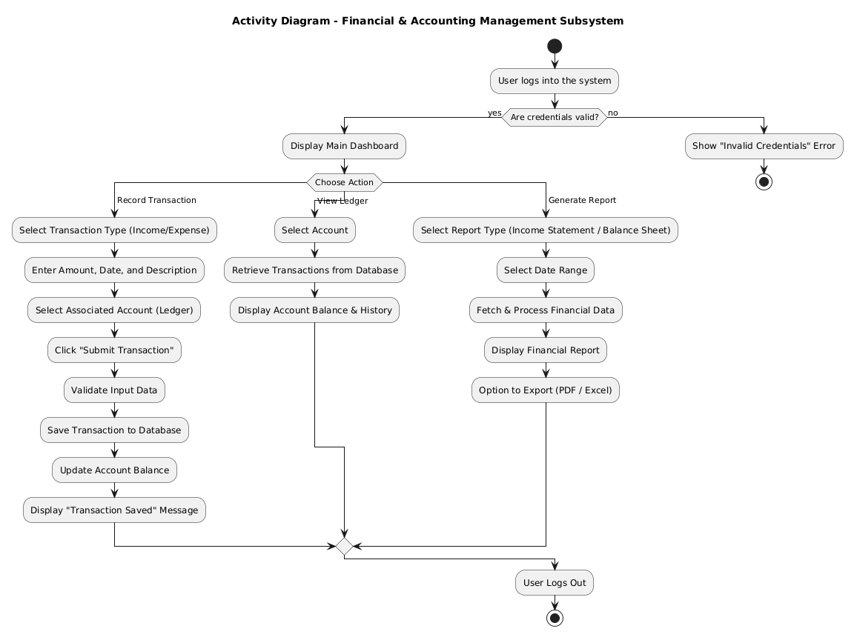

5. STRUCTURE DIAGRAM
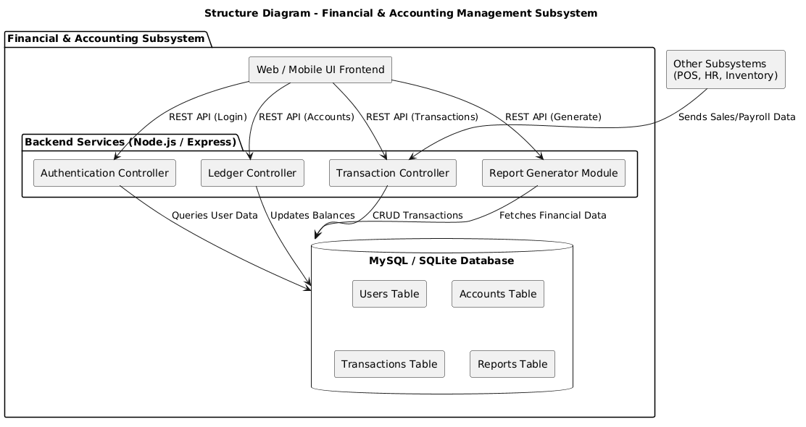

6.COMPOSITE STRUCTURE DIAGRAM
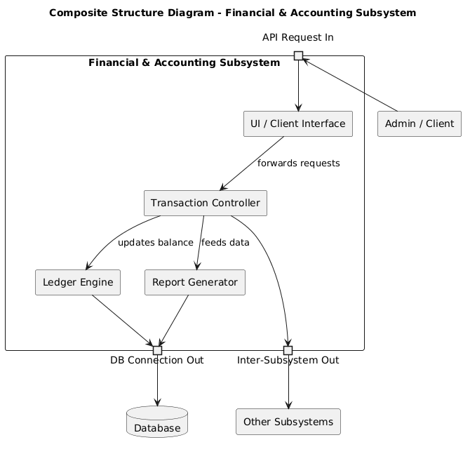

7.DEPLOYMENT DIAGRAM
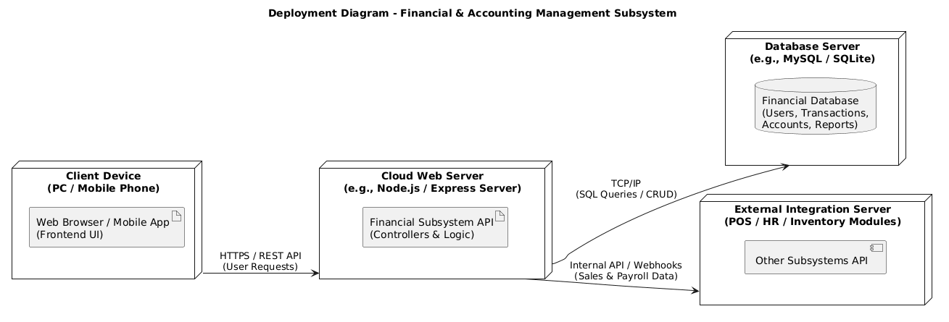

8.OBJECT DIAGRAM
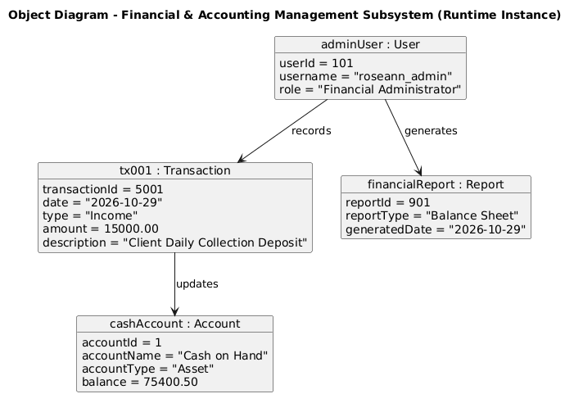

9.PACKAGE DIAGRAM
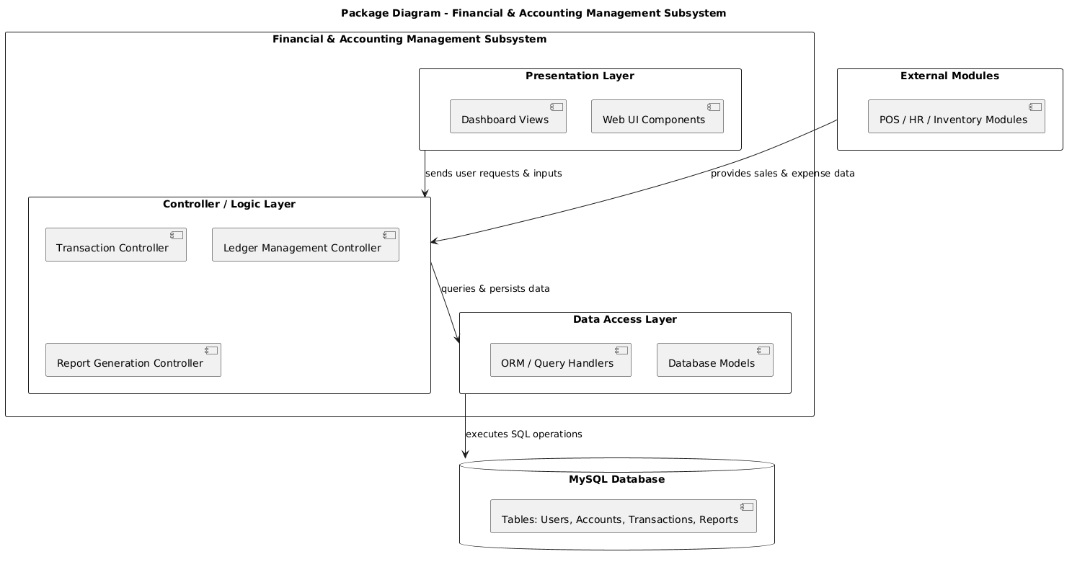

10. PROFILE DIAGRAM
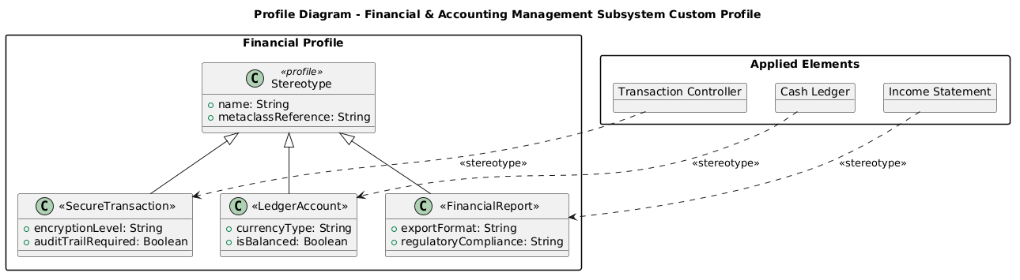

11. STATE MACHINE DIAGRAM
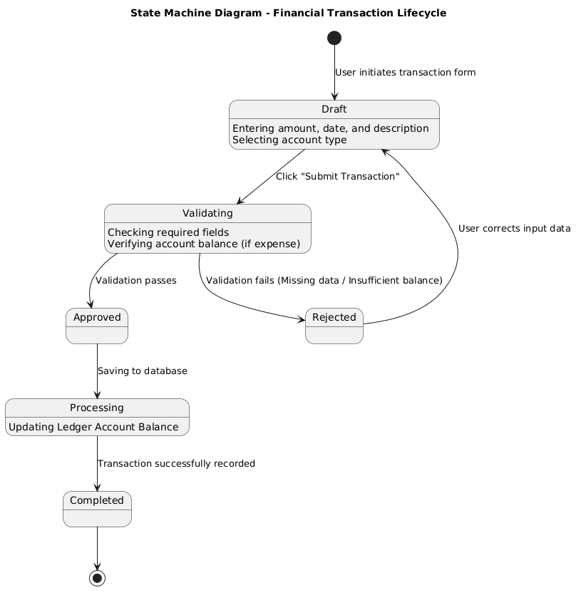

12. USE CASE DIAGRAM
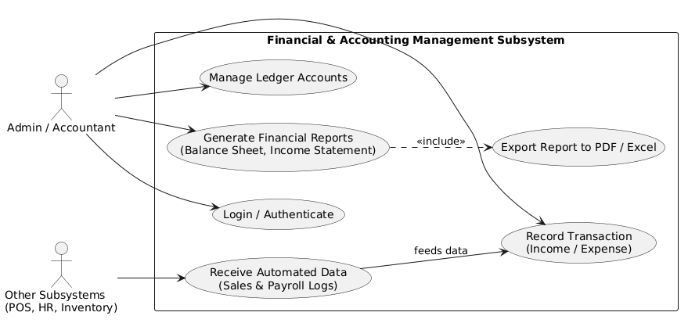

13. COMMUNICATION DIAGRAM
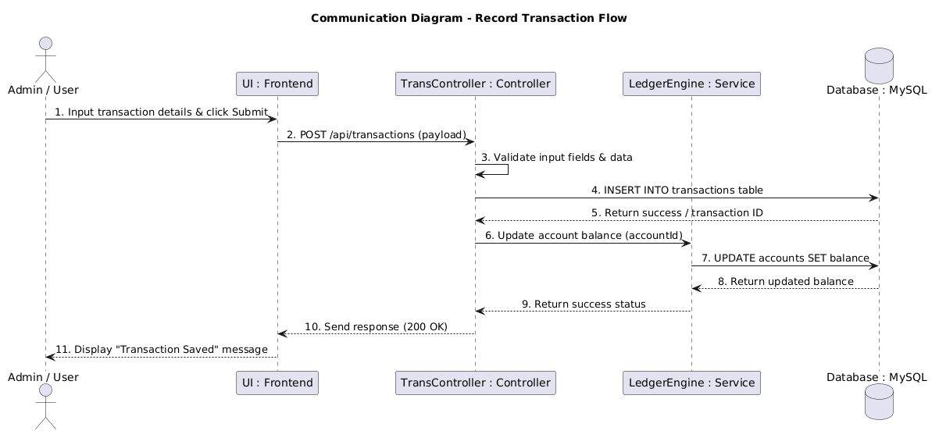

14. INTERACTION DIAGRAM
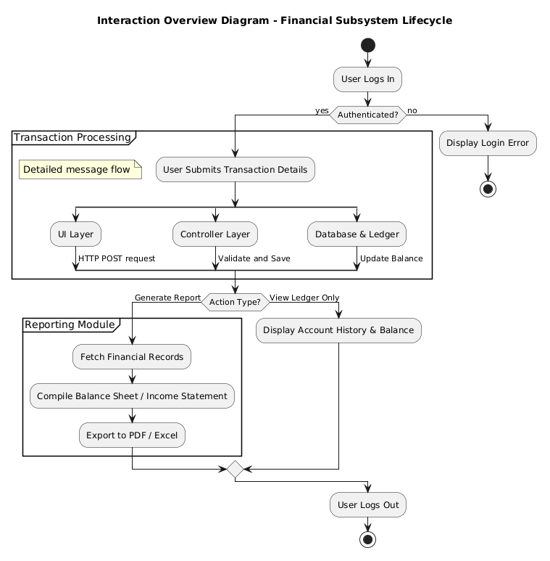

15. SEQUENCE DIAGRAM
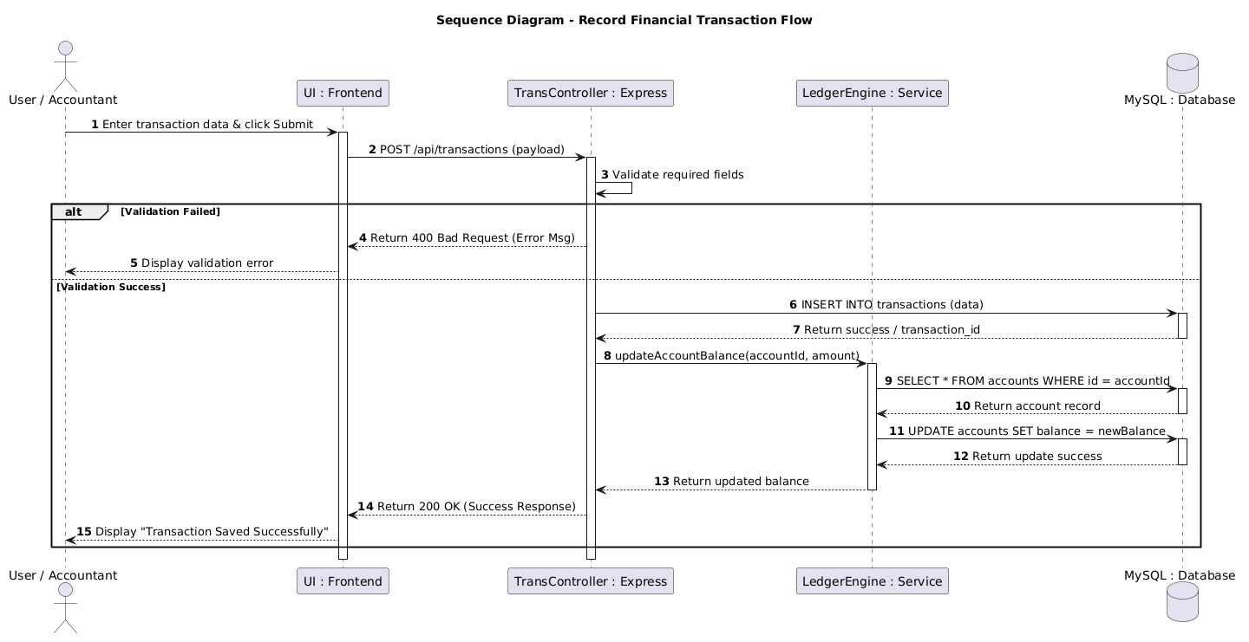
16. TIMING DIAGRAM


